ALGO Trading
Heikin-Ashi Trend Catcher (HA Algo)

- The Heikin-Ashi Trend Catcher is designed to filter out random price noise and identify true market direction. Instead of using raw prices (which jump up and down frequently), it averages and smooths each candle — so trends become clearer and false reversals are reduced.

- Why Use Heikin-Ashi (Dynamic Volatility Filter)
Heikin-Ashi (HA) modifies the traditional OHLC (Open, High, Low, Close) data using averages:
- This smooths out choppy markets.
- It shows clearer trend continuation or reversal signals.
- Small fluctuations are filtered out.

Step 1️⃣ — Dynamic Candle Collection
The algo collects 5 live ticks (prices) to form one price candle.
Each tick represents a small price movement. After 5 ticks, a candle is formed with:
- Open: First tick
- High: Maximum tick
- Low: Minimum tick
- Close: Last tick
⏳ This makes the system adaptive — faster markets will update candles more often, slower markets less often.

Step 2️⃣ — Warm-Up Phase (Learning Market Behavior)
Before taking trades, the algo builds 5 full candles.
This warm-up gives it enough data to:
- Detect early trends
- Calculate initial volatility (via ATR)
- Avoid “blind” trades when the market starts
No trades are taken in this phase — it’s purely for calibration.

Step 3️⃣ — Heikin-Ashi Candle Calculation
Unlike normal candles, Heikin-Ashi (HA) smooths price noise to show clear trends.
Each HA candle is derived as:
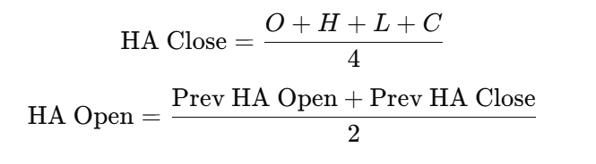
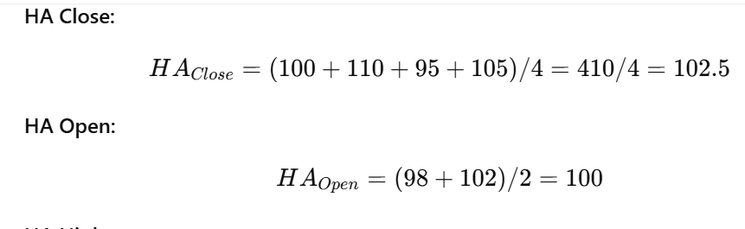

IMP Note:- for Previous HA Open and HA Close
Stage | What Happens | Formula Used
1️⃣ Start | No previous HA → seed with real candle | HA_Open = O, HA_Close = (O+H+L+C)/4
2️⃣ Next Candle | Use previous HA values | HA_Open = (Prev HA_Open + Prev HA_Close)/2
3️⃣ Continue | Repeat for every new tick | Smooth, realistic HA candles form

Then,
- HA High = max(H, HA Open, HA Close)
- HA Low = min(L, HA Open, HA Close)
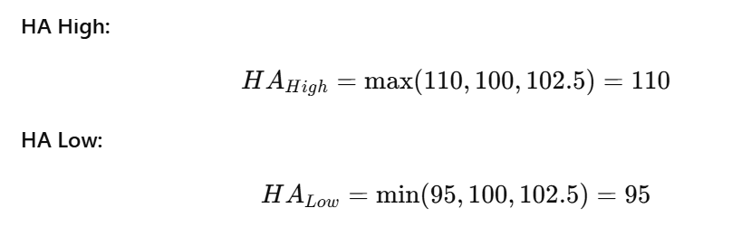
This method filters out volatility and creates visually smoother trends.

Step 4️⃣ — Candle Color = Market Direction
Once the HA candle is computed:
- 🟩 Green Candle: HA Close > HA Open → Uptrend
- 🟥 Red Candle: HA Close < HA Open → Downtrend
This color becomes the trend signal used by the algo.

Step 5️⃣ — ATR Calculation (Volatility Estimation)
ATR = Average True Range, a key measure of market volatility.
It’s computed as:
TR=max(H−L, ∣H−Prev Close∣, ∣L−Prev Close∣)
ATR=Average of TR over 14 candles

TR(14) = [10, 12, 11, 9, 15, 13, 14, 8, 10, 11, 9, 12, 13, 15]
ATR(14) = 162 / 14 = 11.57
📊 If ATR is high → market is volatile → fewer but stronger trends.
If ATR is low → market is calm → shorter, faster trades.

Step 6️⃣ — Transition to Live Trading
After collecting enough candles (5), the algo switches from “warm-up” to “trading mode.”
It now reads each new HA candle in real-time, checking whether the color changes from the previous candle.
This phase marks the start of active decision-making.

Step 7️⃣ — Entry Logic (Trend Confirmation)
The algo uses the HA color to enter trades:
- If HA turns Green → enter LONG (buy)
- If HA turns Red → enter SHORT (sell)
This ensures the system trades with the trend rather than trying to predict reversals.

Step 8️⃣ — Trade Management
Once in a trade:
- The algo continuously monitors unrealized PnL (profit/loss)
- If price moves +0.5% in favor → ✅ Book profit (TAKE PROFIT)
- If price moves −1% against → ❌ Stop Loss (cut trade)
This enforces risk control and ensures small losses with stable profits.

Step 9️⃣ — Equity & Risk Protection
The algo tracks total equity = Capital+ Realized PnL+ Unrealized PnL
If equity ever drops below 95% of starting capital (−5% drawdown),
it stops trading automatically to prevent deep capital loss.

Step 🔟 — Continuous Feedback Loop
After each trade:
- Profit/Loss is logged
- Equity and ATR are updated
- The algo resets and starts collecting new ticks to form the next candle
This loop creates a self-learning trend system that adapts continuously to volatility while keeping emotions out of trading decisions.

💡 In Short
Concept | Role in Algo
Heikin-Ashi | Smooths price noise, clearly defines trend direction.
ATR | Measures volatility, prevents false signals.
Warm-up Phase | Builds data foundation before real trading.
Fixed TP/SL | Ensures strict risk-reward management.
Drawdown Stop | Protects total capital from large losses.

# HeikinAshi_Trend_Catcher_v4.py
import json
import time
import numpy as np
from collections import deque
from datetime import datetime

# ---------------- PARAMETERS ----------------
PRICE_FILE = "price_data.json"
TICKS_PER_CANDLE = 5
WARMUP_CANDLES = 5
ATR_PERIOD = 14
UNITS = 100
TAKE_PROFIT_PCT = 0.005 # +0.5% take profit
STOP_LOSS_PCT = 0.01 # -1% stop loss
BASE_CAPITAL = 100000
DRAWDOWN_STOP_PCT = 0.05
LOOP_SLEEP = 1.2
# --------------------------------------------------

def read_price():
try:
with open(PRICE_FILE, "r") as f:
return float(json.load(f)["price"])
except Exception:
return None

def calc_atr(highs, lows, closes, period=14):
trs = []
for i in range(1, len(highs)):
tr = max(
highs[i] - lows[i],
abs(highs[i] - closes[i - 1]),
abs(lows[i] - closes[i - 1])
)
trs.append(tr)
return np.mean(trs[-period:]) if len(trs) >= period else np.mean(trs) if trs else 0.0

def heikin_ashi_candle(prev_ha, o, h, l, c):
ha_close = (o + h + l + c) / 4
if prev_ha is None:
ha_open = (o + c) / 2
else:
ha_open = (prev_ha["open"] + prev_ha["close"]) / 2
ha_high = max(h, ha_open, ha_close)
ha_low = min(l, ha_open, ha_close)
return {"open": ha_open, "high": ha_high, "low": ha_low, "close": ha_close}

def main():
print("🔥 Starting Heikin-Ashi Trend Catcher Algo")
print("⏳ Collecting live ticks to form initial candles...\n")

tick_buffer = []
candles = []
ha_candles = []
highs, lows, closes = [], [], []
position = 0
entry_price = 0.0
realized_pnl = 0.0
capital = BASE_CAPITAL
prev_ha = None

start_equity = BASE_CAPITAL
stop_equity = start_equity * (1 - DRAWDOWN_STOP_PCT)
trading_live = False

try:
while True:
price = read_price()
if price is None:
print("⚠️ Waiting for price feed...")
time.sleep(1)
continue

tick_buffer.append(price)
print(f"Tick collected: ₹{price:.2f} (buffer {len(tick_buffer)}/{TICKS_PER_CANDLE})")
time.sleep(1.2)

if len(tick_buffer) >= TICKS_PER_CANDLE:
o, h, l, c = tick_buffer[0], max(tick_buffer), min(tick_buffer), tick_buffer[-1]
tick_buffer.clear()

candles.append({"open": o, "high": h, "low": l, "close": c})
highs.append(h)
lows.append(l)
closes.append(c)

ha = heikin_ashi_candle(prev_ha, o, h, l, c)
ha_candles.append(ha)
prev_ha = ha

atr = calc_atr(highs, lows, closes, ATR_PERIOD)
color = "GREEN" if ha["close"] > ha["open"] else "RED"

print("------------------------------------------------------------")
print(f"Candle @ {datetime.now().strftime('%H:%M:%S')}: O:{o:.2f} H:{h:.2f} L:{l:.2f} C:{c:.2f}")
print(f"Heikin-Ashi: O:{ha['open']:.2f} H:{ha['high']:.2f} L:{ha['low']:.2f} C:{ha['close']:.2f} | Color: {color}")
print(f"ATR({ATR_PERIOD}) ≈ ₹{atr:.4f}")

if len(candles) < WARMUP_CANDLES:
print(f"🕒 Warm-up phase ({len(candles)}/{WARMUP_CANDLES})...\n")
continue

if not trading_live:
print("\n✅ Warm-up complete — Trading mode activated!\n")
trading_live = True

equity = capital + realized_pnl + (position * UNITS * (c - entry_price) if position != 0 else 0)
if equity <= stop_equity:
print("\n🚨 STOP — Equity dropped below 5% threshold.")
break

# ---- TRADING LOGIC ----
if position == 0:
if ha["close"] > ha["open"]:
position = 1
entry_price = c
print(f"📈 LONG ENTRY @ ₹{entry_price:.2f} | Reason: Heikin-Ashi turned GREEN (uptrend)")
elif ha["close"] < ha["open"]:
position = -1
entry_price = c
print(f"📉 SHORT ENTRY @ ₹{entry_price:.2f} | Reason: Heikin-Ashi turned RED (downtrend)")

else:
unrealized = position * UNITS * (c - entry_price)
pct_change = (c - entry_price) / entry_price * (1 if position == 1 else -1)
side = "LONG" if position == 1 else "SHORT"

print(f"Position: {side} @ ₹{entry_price:.2f} | Unrealized: ₹{unrealized:.2f} | Change: {pct_change*100:.2f}%")

# Take-profit or Stop-loss
if pct_change >= TAKE_PROFIT_PCT:
realized_pnl += unrealized
print(f"✅ TAKE-PROFIT HIT @ ₹{c:.2f} | PnL: ₹{unrealized:.2f}")
position = 0
elif pct_change <= -STOP_LOSS_PCT:
realized_pnl += unrealized
print(f"❌ STOP-LOSS HIT @ ₹{c:.2f} | PnL: ₹{unrealized:.2f}")
position = 0
else:
print("↔️ Holding position — waiting for target or SL.")

print(f"📊 Equity: ₹{equity:.2f} | Realized PnL: ₹{realized_pnl:.2f}\n")
time.sleep(LOOP_SLEEP)

except KeyboardInterrupt:
print("\n🛑 Interrupted manually.")

finally:
print("\n📘 Final Summary")
print(f"Total Realized PnL: ₹{realized_pnl:.2f}")
print("✅ Algo stopped safely.")

if __name__ == "__main__":
main()

